**Lab Assignment-8**

**Simple API using Express Js, Node Js, MongoDB and Postman**

1. **Index.js (server):**

* Connecting to mongo dB, mongoose and express

const express=require("express");

const mongoose=require("mongoose");

const url='mongodb://127.0.0.1:27017/studentDB';

const app=express();

mongoose.connect(url,{

    useNewUrlParser:true

})

const con =mongoose.connection

con.on('open',function(){

    console.log("connected to mongodb database")

})

app.use(express.json())

const studentRouter=require('./routes/students')

app.use('/students',studentRouter)

app.listen(3000,function(){

    console.log("Server started")

})

1. **students.js**

* Creating routes (GET, PATCH, GET single object by ID, POST)

const express=require("express");

const router=express.Router()

const Student=require('../models/student')

router.get('/',async(req,res)=>{

    try{

        const  stud=await Student.find()

        res.json(stud)

    }catch(err){

        res.send("Error")

    }

    res.send("Get request made")

})

router.get('/:id',async(req,res)=>{

    try{

        const stud1=await Student.findById(req.params.id)

        res.json(stud1)

    }catch(err){

        res.send("Error")

    }

})

router.patch('/:id', async (req, res) => {

    try {

        const studPatch = await Student.findById(req.params.id);

        studPatch.name = req.body.name;

        const s = await studPatch.save();

        res.json(studPatch);

    } catch (err) {

        res.status(500).send("Error"); // Sending an error response

    }

});

router.post('/',async(req,res)=>{

    const student=new Student({

        name: req.body.name,

        course: req.body.course

    })

    try{

        const s=await student.save()

        res.json(s)

    }catch(err){

        res.send("Error")

    }

})

module.exports=router

1. **student.js**

* Creating mongoose schema for a single object (student here)

const mongoose=require("mongoose")

const studSchema=new mongoose.Schema({

    name:{

        type: String,

        required:true

    },

    course:{

        type: String,

        required:true

    }

})

module.exports=mongoose.model('Student',studSchema)

**Output:**

Requests made from Postman API

1. **Get request**

o/p:

1. **Post request**

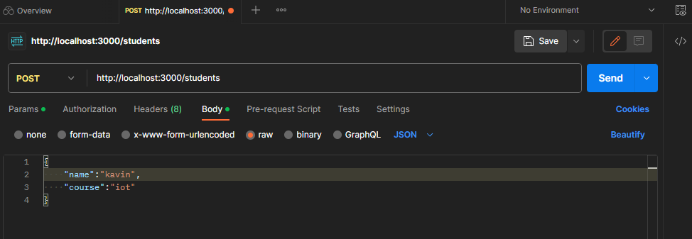

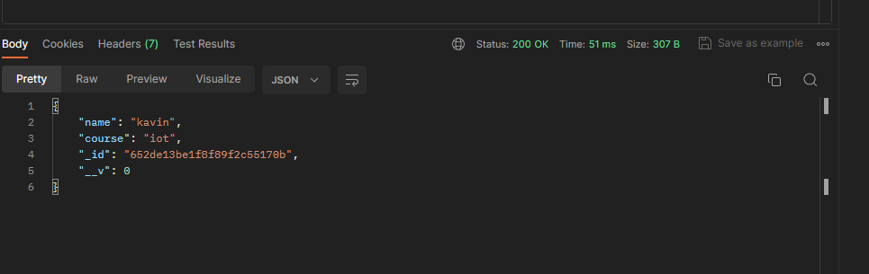

1. **Patch request**

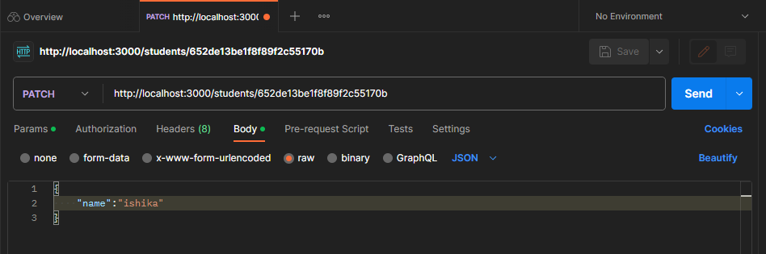

1. **Get by Id**

